SWE.2 - SOFTWARE ARCHITECTURE GUIDELINE

DOCUMENT INFORMATION
 | Information
Document Id | 0404
Document Owner | IAST Software Solutions
Issue Date | 10/06/2024
File Name | Software Architecture Guideline
File Location | -

DOCUMENT HISTORY
Version | Rev Date | Description | Prepared by | Approved by | Status
0.4 | 31/07/2025 | Final baseline of the document as per all the updates from Quality team | Rohith DM | Rakesh Durtati | Approved
0.3 | 31/07/2025 | Initiating review after final changes being done as per updated RMP | Rohith DM |  | In-Review
0.2 | 19/12/2024 | Initiating the review of Software Architecture guideline. | Ayush Verma |  | Re-work
0.2 | 18/12/2024 | Reworking on the review findings from Quality Team | Ayush Verma |  | Re-work
0.1 | 10/06/2024 | Started Preparing the Software Architecture Guideline | Ayush Verma |  | Draft

Table of Contents

DOCUMENT INFORMATION 2
DOCUMENT HISTORY 2
1. INTRODUCTION 5
2. ARCHITECTURAL DESIGN RULES: 6
a) Package Structure of a Component 6
b) Component Design - Context View Design Rules: 7
c) Component Design - Dynamic View Design Rules: 9
3. NAMINIG CONVENTION RULES: - 10
4. HOW TO: - 10
a) Select AUTOSAR Ports 10
b) Mark a Port as Scheduled Function 11
c) Integrate to Polarion 11
1) Polarion Review & Document Process 14
2) Key Points to remember: 16
5. Functional Description 16
6. Analysis Result………………………………………………………………………………………………………………………….16
7. Software Architecture attributes………………………………………………………………………………………………16
8. Baseline Strategy………………………………………………………………………………………………………………………17
List of Figures 17

INTRODUCTION
Enterprise Architect (EA) is a holistic approach to managing the complexities of organizations, aligning IT resources with business goals, and optimizing processes for efficiency and effectiveness. It involves creating a blueprint that defines the structure and operation of an organization, including its information systems, technology infrastructure, business processes, and organizational structure.
UML (Unified Modelling Language) is a standardized modelling language used in software engineering for visualizing, specifying, constructing, and documenting the artifacts of software systems. It provides a set of graphical notation techniques to create models of software systems.
When developing software architecture using UML, here are some steps one shall follow:
- Identify Requirements: Understand the functional and non-functional requirements of the software system.
- Create Use Case Diagrams: Use case diagrams help to identify the interactions between the system and its users, depicting the functional requirements of the system.
- Design Class Diagrams: Class diagrams depict the static structure of the system, showing classes, their attributes, methods, and relationships.
- Draw Sequence Diagrams: Sequence diagrams illustrate how components interact in a scenario of a use case, showing the flow of messages between components over time.
- Develop Component Diagrams: Component diagrams represent the components of the system and their dependencies, helping to visualize the high-level organization of the software.
- Design Deployment Diagrams: Deployment diagrams show the physical deployment of artifacts on nodes, such as servers or hardware devices, helping to understand the system's deployment architecture.
- Document with Activity Diagrams: Activity diagrams illustrate the workflow of a system, depicting the flow of activities and actions.
- Review and Refine: Iterate through the design process, reviewing and refining the architecture based on feedback and changes in requirements.
Through the integration of EA tools and UML design, software architects can streamline the architecture development process, improve collaboration among stakeholders, and ensure that the resulting architecture aligns with both business and technical requirements. This guideline will delve into the key principles, methodologies, and best practices for leveraging EA tools and UML design in software architecture development.

ARCHITECTURAL DESIGN RULES:

- ADR – The visibility of functions and ports shall be deactivated in the overall architectural view.
- ADR – The colours of the components and lifecycles shall be the default colour set by Sparx Enterprise Architecture.

Package Structure of a Component

- ADR_C1 – The top-level package with the stereotype Component shall have the same name as the component under design consideration.
- ADR_C2 - Below the Component, the structure shall be organized as follows:

  - Component Design: The design shall incorporate Dynamic View and Context View.

- Each Component shall incorporate Component Design, independently of the implemented requirements.
- Context View: The view shall contain at least one Component Diagram.
- Dynamic View: The view shall contain at least one Sequence Diagram.

  - Unit Design: The design shall incorporate Class Diagrams and Unit Diagrams.

- Class Diagram: The diagram shall contain all C-functions (units) and variables which can be accessed by all functions of components.
- Unit Diagram: The diagram contains Static and Dynamic View of the respective unit.
- Static View: The view shall contain a Class Diagram which shall describe the interfaces of the Unit under consideration.
- Dynamic View: The view shall contain either a State Diagram or an Activity Diagram.

Component Design - Context View Design Rules:

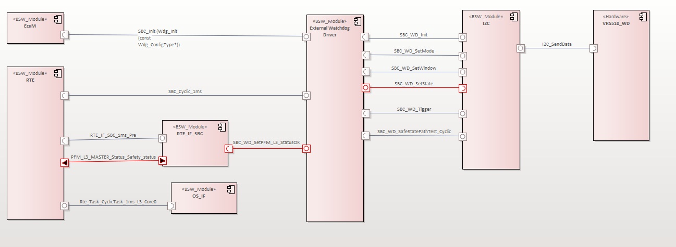
Figure 1: SBC External Watchdog Component Diagram

- ADR_CV1 – The link of the component shall be present in the Component Design overall view.
Note: - Component Design Overall View is the composite diagram consisting of all the modules in the scope of the IAST as discussed with customers.
- ADR_CV2 – The link of the component shall be present in the Unit Design overall view.
- ADR_CV3 – The component under architectural design consideration in the Context Diagram shall be placed on the top of the diagram.
- ADR_CV4 – The component under consideration in the Context Diagram shall contain all its ports.
Exception, the third-party components shall contain only the ports which are being used at the static port.
- ADR_CV5 – The components in the Context Diagram that are lower in hierarchy layer shall be placed on the right-hand side of the component under consideration.
- ADR_CV6 – The components in the Context Diagram that are higher in hierarchy layer shall be placed on the left-hand side of the component under consideration.
- ADR_CV7 – The components in the Static Diagram that are same in the hierarchy layer shall be placed below the component under consideration.
If components share common interface, it shall be depicted with a vertical line but shall be labelled horizontally.

- ADR_CV8: All the components shall contain the ports which are connected to the component that is under consideration.
Note: Due to above rule the architecture might become crowded so, one component diagram can be used to depict multiple ports of interfaces communicating with the component under consideration and each other.
- ADR_CV9: The component relationship shall be a “Delegate”, and its direction shall be set to “Unspecified”. It shall be drawn horizontally.
- ADR_CV10: The Delegate component relationship shall connect either through a Receiver Port and a Sender Port or through a Client Port and Server Port.
- ADR_CV11: The components shall not show function names inside the component box.
Exception, if a function is called from a task, then that function shall be marked as a “Scheduled Function”.
- ADR_CV12: The components that have more than one function, one AUTOSAR Client/Server or AUTOSAR Sender/Receiver Port for each AUTOSAR Port shall be drawn and NOT for each function.
- ADR_CV13: The ports in the Component Diagram shall be copied as links, using “Copy-Paste” option if they are used in different diagrams.
- ADR_CV14: The AUTOSAR Client/Server or Sender/Receiver Ports attached to the interfaced components shall have the name of corresponding external functions that is being communicated between the interfaces.
- ADR_CV15: The Component Diagram shall not consist of any unused AUTOSAR Client/Server or AUTOSAR Sender/Receiver Ports.
- ADR_CV16: The Object, which is supposed to be deleted, shall be deleted exclusively from “Project Browser”.
- ADR_CV17: The name of the functions shall be placed just over the Component Relationship connector in the component diagram.
- ADR_CV18: The parameters shall not be specified in the component diagram.
Exception: If a single function is being used multiple times, then the parameters distinguishing the function calls shall be specified.
- ADR_CV19: In the component diagram the function calls which are SW_L3 Safety relevant shall be depicted using red colour.
- ADR_CV20: The component diagram shall contain a Legend, if Safety related function calls are present to display the distinction between ASIL and QM.

Component Design - Dynamic View Design Rules:

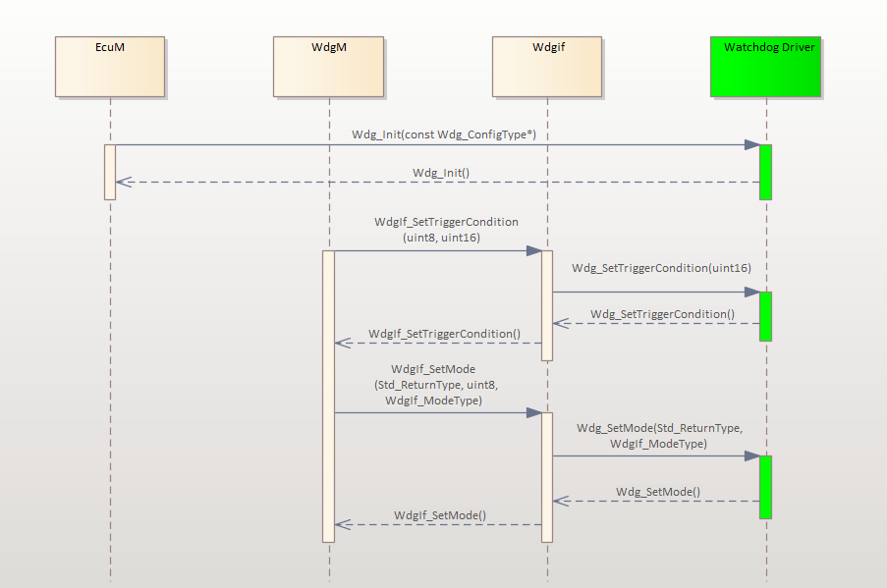
Figure 2: SBC External Watchdog Sequence Diagram

- ADR_DV1: Each public interface of a component shall be covered by at least one sequence diagram.
- ADR_DV2: If the functional call in the sequence diagram is synchronous then for each function a message and a corresponding return message shall be drawn.
- ADR_DV3: If the functional call in the sequence diagram is asynchronous then no return message shall be drawn.
- ADR_DV4: In a sequence diagram only the safety related function calls shall consist of project parameters and respective return values.
- ADR_DV5: The safety related function calls in the sequence diagram shall be depicted using red colour.
- ADR_DV6: The sequence diagram shall have an appropriate number of sequences.
Note: The sequence diagram shall not depict all possible combination of function calls.
- ADR_DV7: The sequence diagram shall depict the periodicity of the task if the “Main” Function is being called by an Operating System task.
- ADR_DV8: The return signals of the sequence diagram shall not have name.
The sequence that proceeds the respective return signal shall be depicted using the “Fragment” element from “Interaction” part of Toolbox.

NAMINIG CONVENTION RULES: -

The following naming convention shall be used in projects requiring Software Architecture:
“ProjectName_ComponentName2_ComponentName1_TYPE_Diagram”
where,
ProjectName = Name of the working project
ComponentName1 = Major Component
ComponentName2 = Component under consideration

Note: - Every project has its own Project Management Plan, the priority for naming convention should be given to Project Management Plan. The Guideline is for reference.

HOW TO: -

a) Select AUTOSAR Ports

The architect shall follow following steps to select AUTOSAR Ports: -
- Select “Port” from the Component Section of Toolbox.
- Drag and drop the port inside the component where port must be placed.
- Double click on the “Port” and fill the name of the port as the name of the function.
- Click “Edit” beside “Stereotype” attribute. Set “Perspective” attribute to “All Perspectives” and “Profile” attribute to “AUTOSAR Components and Ports”.
- From the Stereotypes Column select which type of port is to be used. Click “OK” and close both the Stereotype box and the Port Box.
- Double click on the port again to select the direction of the selected port.
- Go to “AUTOSAR Components and Ports” tab and select the intended direction of the selected port.
Note: One shall close the Port Box and again open it by double clicking on it as it will not allow to change the direction of the port first time.

b) Mark a Port as Scheduled Function

The architect shall either create a Schedule Function Entity if not already present. Following are the steps to create a scheduled function entity: -
- Select the AUTOSAR Port that must be marked as Scheduled Function.
- Right click and select go to “Features” section and select “Interaction Points”.
- Right click under “Interaction Points” and select “Add New” option.
- The “Insert New Embedded Element” box will pop-up. Click “Edit” beside the “Stereotype” attribute.
- Click “New” button and type in the name of New Stereotype “Scheduled Function”.
- Select the newly created “Scheduled Function” element from the list and click “OK”.
- Click “OK” in the “Insert New Embedded Element” box.

After creating the “Scheduled Function” element the architect can select the element by following steps:
- Follow the above-mentioned steps from Step-1 to Step-4.
- Select the “Scheduled Function” element from the list and click “OK”.
- Click “OK” in the “Insert New Embedded Element” box.

Integrate to Polarion

The architect shall follow the below procedure to export the Software Architecture from Sparx Enterprise Architect to Polarion:

Steps to Connect to Cloud in Enterprise Architect (EA):
  - Initialize the Enterprise Architect (EA) application
  - Open the project server, where architectures have been designed.
  - Connect to the Cloud server of the respective project. Example: - Add this details to access the CGVCU Architecture repository:
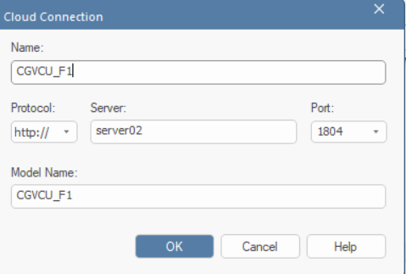
Figure 3: Cloud Server Connection Selection

EA Export to Polarion:

  - Select on the Module’s Architecture folder you would like to export from Sparx Enterprise Architect to Polarion.
  - Right click on the Module’s Architecture folder you would like to export from Sparx Enterprise Architect to Polarion.
  - Click on the “Specialize” option and select the “Polarion Integrator” option from the dropdown list.
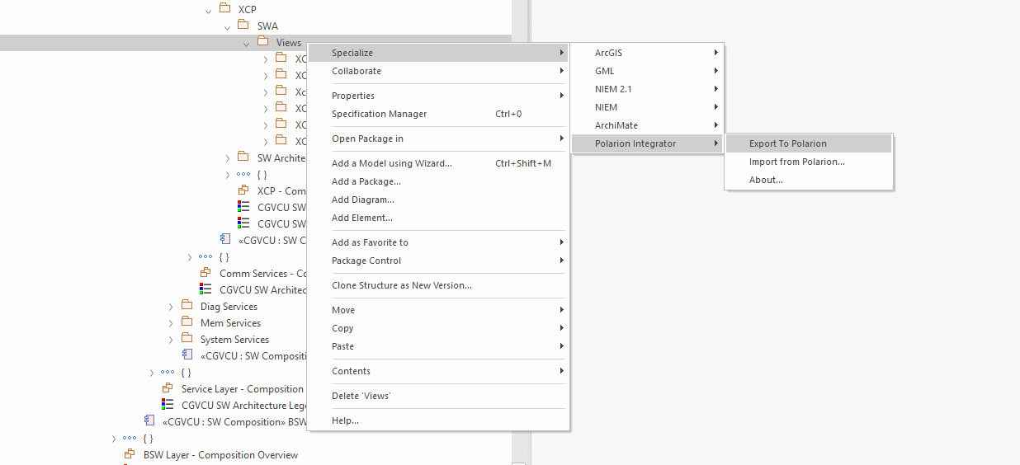
Figure 4: Folder Selection and Exporting to Polarion
  - Enter the required details for the required project in the Pop-Up box that appears and enter your Polarion credentials (ID and Password).

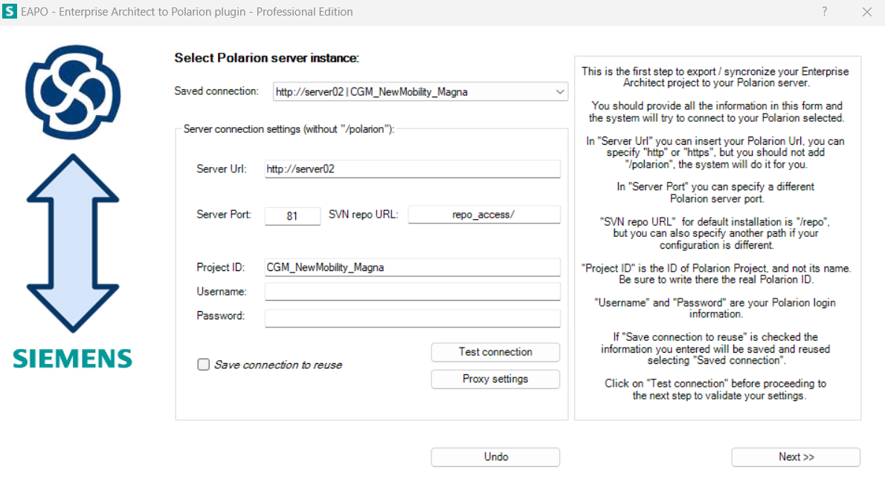
Figure 5: Server Connection and Testing Connection
  - Select the “New Mapping” option then give the name as “Module_Number” for preparing the local Database.
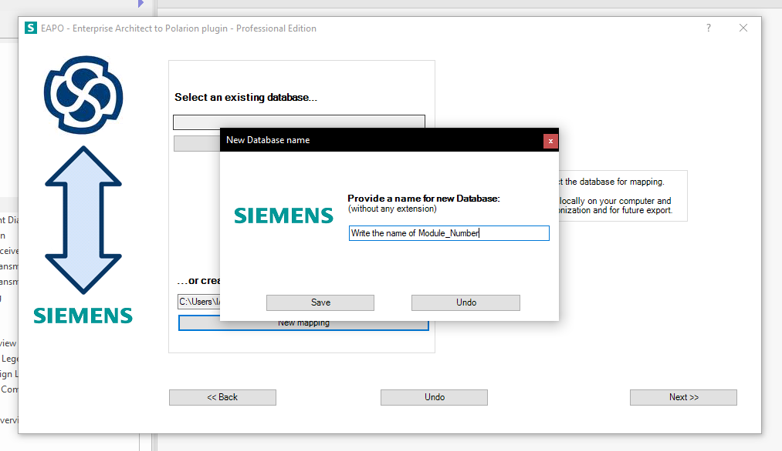
Figure 6: New Mapping and Name for Database
  - Select the Polarion Type of every item or required items, by selecting the “Software Architecture” by clicking on the dropdown option on Polarion Type section.

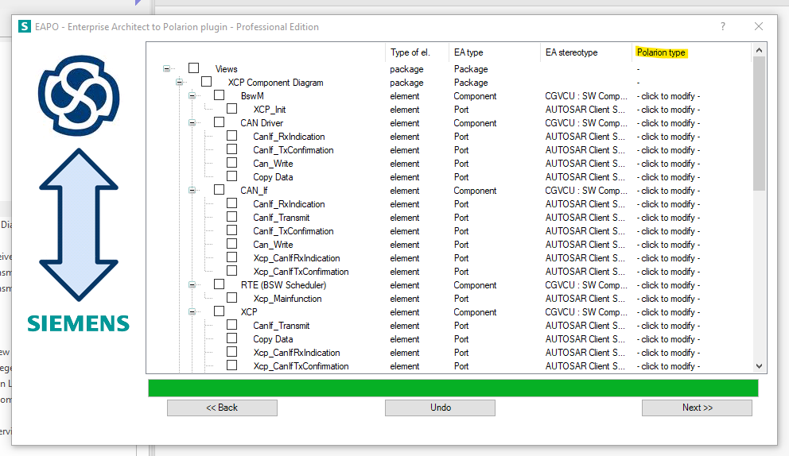
Figure 7: Selecting Polarion Type for Required Elements
  - Click on the Next Button then the Export of the selected elements will start.
  - The export results will pop up which means the selected elements have been exported successfully and, if it doesn’t it means the architecture have not been exported.

Polarion Review & Document Process

Document Process:
  - The Document History section of the Polarion Document should be updated before every baseline.
  - The Scope and Purpose section of the Polarion Document should be updated.
  - Status of pulled elements, especially the architectural designs, should be updated from “Draft” to “Proposed” and finally to “In-Review” when creating baselines and even while moving the elements to document.

Review Process:

1) Verification Review:
  - Firstly, verification review baseline will be created and will be sent for review with Verification review task.
  - Document history, status of architecture should be checked before creating baseline
  - Link the architecture with Verification review task.

  - It will have two checklists with status as follows:
    - Draft – At the time of sending it for review.
    - Completed – At the time when reviewed baseline is created.
  - The task will have CFR review baseline and Verification review baseline.
  - Resolve the review findings and send it for CFR review after it.
  - Once the CFR review task is accepted Verification review task will also be accepted till then it will be in Done status.

2) Cross-Functional Review:
- Once the Verification review task is in done status, you will create a Cross-function review baseline and sent it for review with CFR review task.
- Document history, status of architecture should be checked before creating baseline
- Link the architecture with CFR review task.
- It will have two checklists with status as follows:
  - Draft – At the time of sending it for review.
  - Completed – At the time when reviewed baseline is created.
- The task will have CFR review baseline and reviewed baseline.
- Once the comments have been resolved the review findings both the review tasks should be in accepted.
- Attach the reviewed baseline in verification review task.
- Attach the review findings mail as pdf if any received through mail.
- Attach the checklist and confirm it is updated.

Internal Approval:

      - Now when we have both the Verification review and CFR tasks in “Accepted” state, the document will be sent for Approval from Architect Expert.
      - This approval will be the final version of the document which is being shared with the customer with 100% module maturity.
      - A baseline will be created for the same in the document in the format “CGVCU_ModuleName_InternalApproved_SWE.2_ddmmyyyy”
      - This also suggests that there will be no further modification in the module document.

Key Points to remember:
- Create new mapping every time and delete the old work item after rework.
- Update the checklists.
- Updated the review tasks.
- Update the Author name in EA.
- If the Software Architecture is linked to multiple parent requirements and if they have different ASIL levels then the Software Architecture shall take the highest ASIL level of the input requirement, with ASIL D being the highest safety level and ASIL A being the lowest safety level.

5.Functional Description
To brief much about the API(s)/ Interfaces that we have shown in the Architecture, a separate section has been added at the end of the document called Functional Description. Here we have briefed about all the API(s) shown in the architecture with its syntax and the parameters enclosed.

6.Analysis Result
In Order to prepare an Architecture diagram, a pre-requisite analysis is made on the Module. The input would be the generic Autosar SWS and the SWE.1 requirements. After the analysis of the same, the necessary modules are captured and the interfaces or the API(s) for the communication are indicated via client/server ports for the Context View. The dynamic view is also shown for the same in the order of events/API(s) being called.

7.Software Architecture Attributes
  - Artifact Type
  - Status
  - Categories
  - Cyber Security
  - Safety
  - ASIL Levels
  - Severity
  - Milestone
  - Feasibility
  - Risk

8.Baseline Strategy
For any module for which the Software Architecture is done, we basically have 4 different baselines that are maintained in the document.
  - Verification Review Baseline: The first baseline which is created when sending the module to peer review.
Syntax: CGVCU_ModuleName_VerificationReview_SWE.2_ddmmyyyy

  - Cross Functional Review Baseline: If there are any fixes to be done from peer review, the modifications are done and then sent to CFR (A member each from Development, Validation and Safety). When sending to CFR, a baseline is created as shown below
Syntax: CGVCU_ModuleName_CrossFunctionalReview_SWE.2_ddmmyyyy

  - Reviewed Baseline: After doing the fixes if any from CFR, a Reviewed baseline is created after moving all the workitems to reviewed state.
Syntax: CGVCU_ModuleName_Reviewed_SWE.2_ddmmyyyy

  - Internal Approved Baseline: After the reviewed baseline is created, the document is sent for approval from an Expert from internal IAST team. After the approval from the expert, a baseline is created as shown below
Syntax: CGVCU_ModuleName_InternalAppoved_SWE.2_ddmmyyyy

List of Figures
Figure 1: SBC External Watchdog Component Diagram 6
Figure 2: SBC External Watchdog Sequence Diagram 8
Figure 3: Cloud Server Connection Selection 11
Figure 4: Folder Selection and Exporting to Polarion 11
Figure 5: Server Connection and Testing Connection 12
Figure 6: New Mapping and Name for Database 12
Figure 7: Selecting Polarion Type for Required Elements 13

